Date:17.05.2022

**Third Year B. Tech., Sem VI 2021-22**

**4CS372 : Advanced Database System Lab**

**LA - 3 Submission**

**PRN No: 2019BTECS00064**

**Full name: Kunal Santosh Kadam**

**Batch: T2**

**Title of assignment: LA3 (ESE)**

Creation of Database

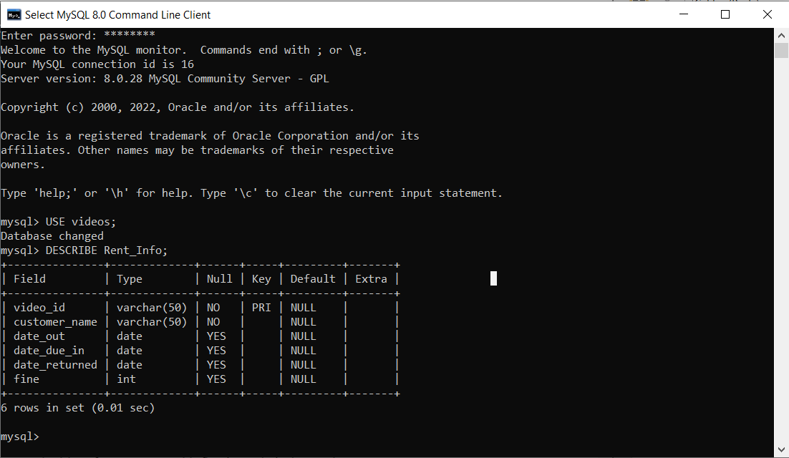

Connection to Database:

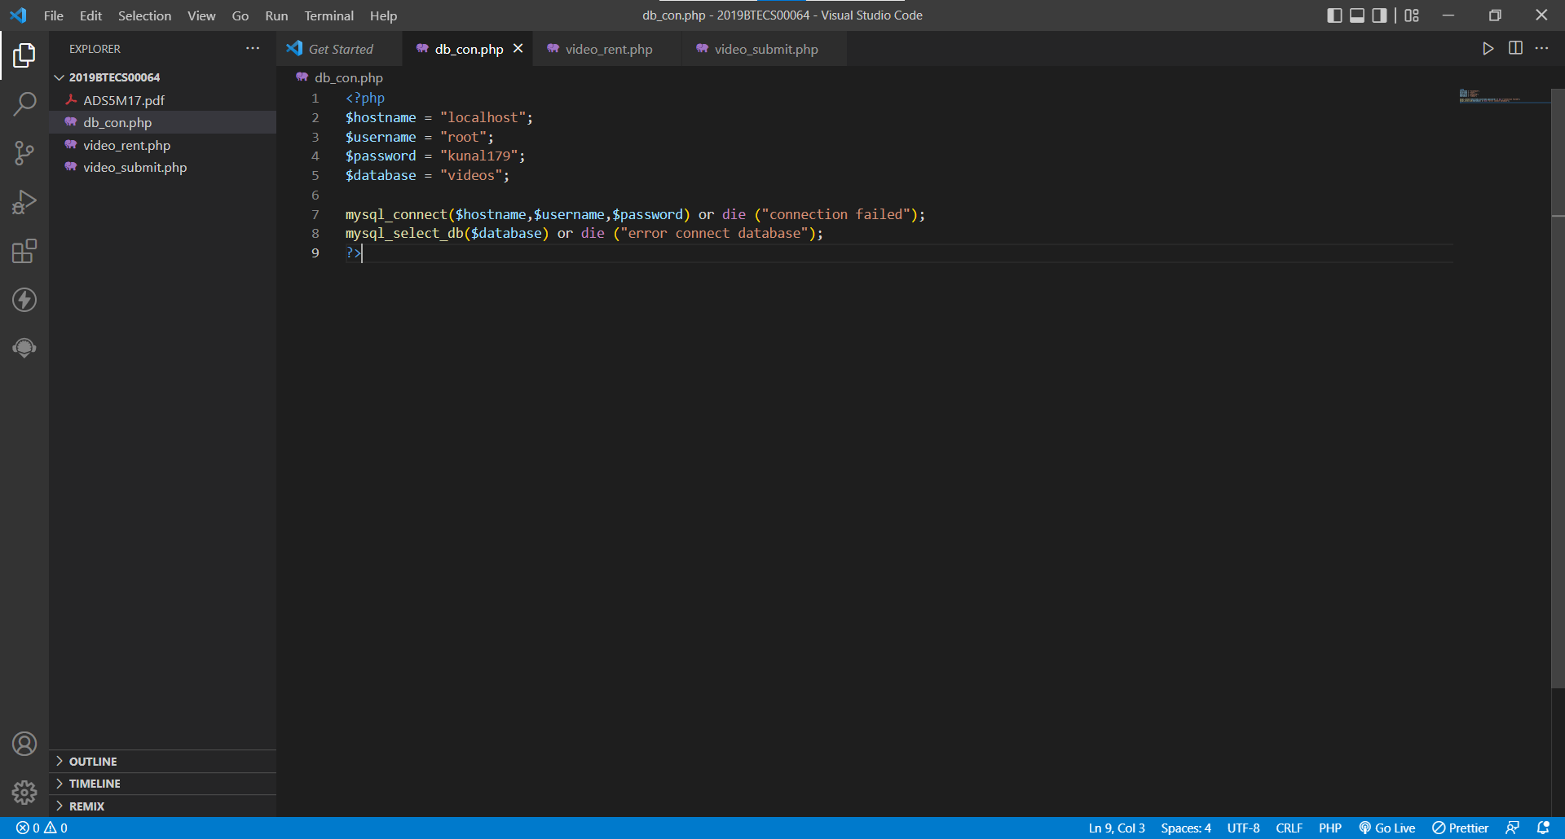

Writing code to insert data

